SciptChain LLC
Goal:
1) To build an efficient decentralized communication network between EHR systems, health care providers, and patients. Generate real-time anal
2) To generate real-time analytics of a patient’s health based on his/her medical history.
Users: Healthcare providers, Patients.
The figure below shows the interaction between our applications and EHR systems, the interactions of the users with our system.
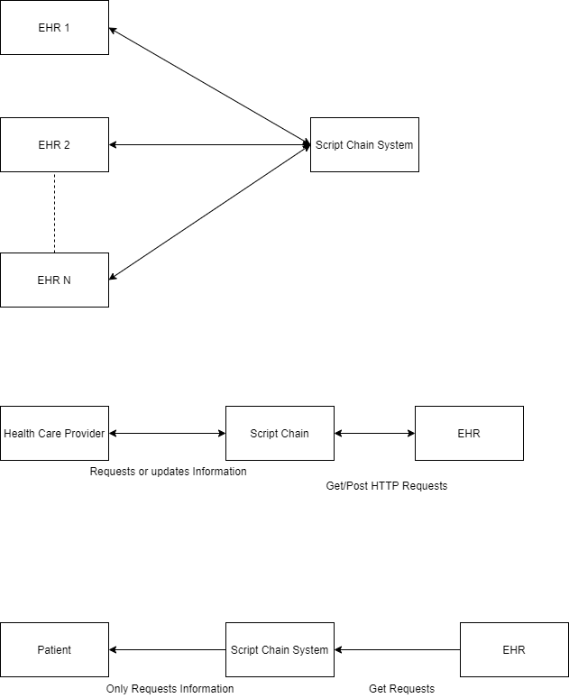

Use Case 1: Interoperability between healthcare providers, users and EHR systems.
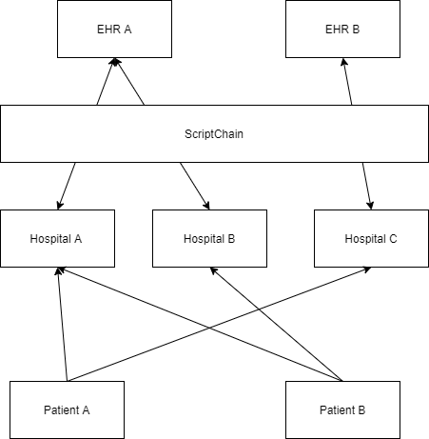

- Let us a patient visits hospital A in his first visit, and then he visits hospital B in his second visit. From the above diagram we can see that hospital A and B both use different EHR systems. So, in his second visit a physician may not be able to access information of the previous diagnosis of the patient. Our platform solves this problem by providing a decentralized communication network between these entities.
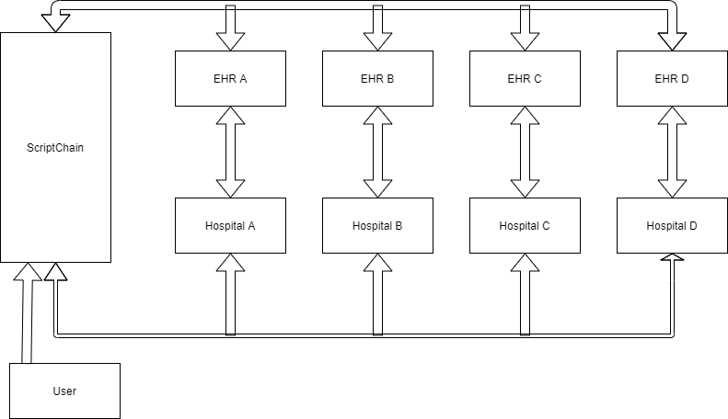

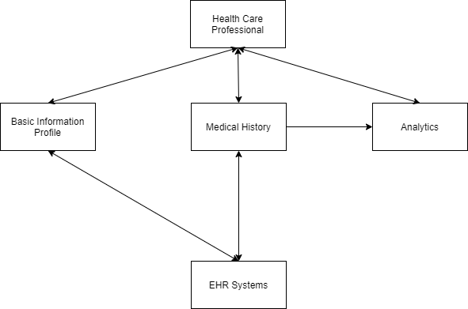
Use Case 2 (Real-time Analytics):

We provide real-time analytics of a patient’s health based on his/her medical history. We leverage the power of AI and Machine Learning to build reliable systems to generate the analytics.

